Nine Mile Ride Primary

Focus
A booklet that offers clarity around the process and procedures for behaviour at NMR. Click here to access the behaviour policy.
BEHAVIOUR BOOKLET
Process and Procedures
Behaviour Expectations at NMR

“Children are not born with an understanding of the rules of acceptable behaviour – they have to learn them, and need adults help to do this.”

Appendix A: | Appendix B | Appendix C
Behaviour Standards and Expectations | Golden Rules  Rights and Responsibilities | Smiley Expectations

Appendix E | Appendix F | Appendix G
Ladder of Consequences | Orange Zone/Red zone letters | Success Contract

THE EVIDENCE

Positive Pupil Behaviour Supports Learning
Positive pupil behaviour supports learning. Willingham’s (2009) Simple Model of Memory outlines that pupils learn what they attend to. If pupils are not listening to the teacher or are distracted by poor behaviour from others in the classroom, then they are not thinking actively and effortfully about the content being taught. Active and effortful thinking is important if new knowledge is to be transferred from the working memory to the long-term memory (Willingham, 2009). Pupils need to be focussing on new items of knowledge in working memory so that they are able to make links with prior knowledge stored in the long-term memory in order to contextualise new knowledge. Inappropriate behaviour in a lesson is distracting which prevents the pupil and others from accessing the learning successfully.

Establishing a positive classroom environment, conducive to learning, is important because pupils are influenced by peer culture and social norms (Bennett, 2017). If a pupil sees others in their class engaging in low-level disruption or not doing their homework with no consequences, they may accept this as the social norm of the classroom environment and adjust their own behaviours (Didau & Rose, 2016). On the other hand, if the classroom norms are ones where the majority of pupils are well behaved and hardworking, those who are not aligned may be encouraged to work harder if they realise that they are in the minority. Teachers are also susceptible to social norms and school leaders can look to influence the social norms amongst their staff by modelling, to teachers, positive interactions with pupils and how to make expectations clear.

If there is no positive behaviour for learning present, then it is unlikely that pupils will be motivated to learn. Feeling successful can be a really key motivator to learning (Mccrea, 2021). When pupils are surrounded by poor classroom behaviour and are themselves distracted, they are prevented from being successful which, over the long-term, reduces their motivation to learn and, in turn, affects outcomes. Praising good behaviour helps highlight desirable social norms and motivates pupils (and teachers) to make positive choices (Didau & Rose, 2016). How pupils are grouped are also important; care should be taken to monitor the impact of groupings on pupil attainment, behaviour, and motivation.

As well as being an important determiner of academic outcomes, having positive behaviour for learning supports pupil and teacher wellbeing. Inappropriate behaviour can make pupils and teachers feel unsafe which can affect their wellbeing (Education Endowment Foundation [EEF], 2019). When someone is stressed or anxious (whether this be a pupil or a teacher), this takes up valuable capacity in the working memory (Sweller et al., 2019), reducing the amount of cognitive load able to be allocated to the pupil learning effectively or to the teacher teaching effectively, as well as impacting upon the social development of the pupil.
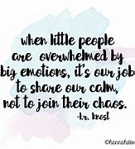
Purpose of this booklet
The primary purpose of this booklet is to offer clarity around the process and procedures for standards of behaviour in Nine Mile Ride Primary School. We currently have in place a Circle Trust behaviour policy (click here to access); however, this information will not help with the day to day management. The processes and procedures are evidence-based so that our decisions are successful because they are research-based.

Introduction

Nine Mile Ride Primary is a calm and well-ordered learning environment within which pupils thrive academically whilst growing socially. We value learning above all else and so deal swiftly with anything that disturbs this core purpose. We value high quality relationships and value each person within the school.

Nine Mile Ride is committed to setting high standards of behaviour for all our pupils and promotes positive approaches to difference and fosters respect for people, property.

Language or behaviour which is offensive, racist, sexist, homophobic or potentially damaging to any child will not be tolerated. Our aim is that all learners achieve the highest educational standards and as such we take action if there is disruption to learning or harm to the wellbeing of a child at the school.

We recognise that at Nine Mile Ride Primary, learning needs to take place in a welcoming and caring environment where relationships between parents/carers, staff and children are based on respect. Wherever possible the school aims to use positive strategies for behaviour management and will work in partnership to promote our values.

Nine Mile Ride Primary School follows a set of values that underpin all interactions with children, adults and the whole school community. We expect all our stakeholders to abide and promote them. The values are:

How to Support Good Behaviour for Learning

Behaviour management is about more than addressing inappropriate behaviour; it is also about encouraging and celebrating positive behaviours (Epstein et al., 2008). Whilst many approaches to behaviour are reactive and focus on ‘correcting’ inappropriate behaviours after they have occurred (Muijs & Reynolds, 2011), proactive approaches increase the chance of pupils experiencing success. Feeling success in learning is correlated with higher levels of life satisfaction, which support pupils to develop resilience and belief in their own ability to succeed (Rathman et al., 2018; OECD, 2015).

As adults, it is our job to:

Communicate Clear Expectations
All staff have a responsibility to provide a safe environment in which children can learn and it is, therefore, important that all staff are aware of the importance of rigorously maintaining clear behavioural expectations. Our pupils will benefit when the classroom is a predictable place. Setting clear expectations minimise opportunities for misunderstandings, which can lead to misbehaviour. We need to be able to clearly explain what their expectations are, at the beginning of the school year, reinforce these consistently across the year, and teach pupils to follow them.
Establish and Reinforce Routines
Another way we can support both pupils and staff is to reduce the load on working memory during lessons by establishing routines. If something occurs repeatedly in lessons, it can be turned into a routine (McCrea, 2020). Routines make frequently occurring processes automatic. When routines become automated, this helps to reduce pupil cognitive load and frees up capacity in the working memory for the new learning in the lesson (Sweller et al., 2019).
Teaching of Model Behaviours
Another way we can be proactive in reducing the need to manage misbehaviour is through the modelling of learning behaviours. Learning behaviours are any behaviours which support pupils to learn, for example; being able to get attention from a teacher; knowing what to do when you are stuck, or expressing your spoken ideas in sentences (EEF 2019). Research suggests that teaching learning behaviours has a positive impact on pupils’ academic achievement and cognitive ability (McDermott et al., 2001). This is because pupils who are aware of their own behaviour and have strategies for self-regulation are ‘less likely to misbehave at school’ and so teachers should encourage pupils to be self-reflective of their own behaviour (EEF, 2019. p.16).
Motivating Pupils to meet high Expectations
A classroom culture conducive to learning is one of high expectations where pupils are expected to, and supported to, achieve (Bennett,2017) and research suggests a correlation between teacher expectations and pupil achievement (Dusek & Josesph, 1983; Cooper, 2000). High expectations can be communicated to pupils through intentional, clear, positive and consistent language that promotes challenge and aspirations for all pupils and colleagues (DfE 2019a). As staff, we should invest time in creating a positive, motivating environment, where there is an understanding that making mistakes and learning from them and the need for effort and perseverance are part of the daily routine.
Building Relationships
The quality of teacher-pupil relationships is another key motivating factor (Coe et al., 2020). Forming positive relationships with pupils - by giving purposeful praise, celebrating effort, sharing success, and where pupils believe that their feelings will be considered and understood - can help teachers to foster a sense of achievement within their classroom and have an impact on behaviour (EEF, 2019). Positive behaviour is more likely to thrive when relationships at all levels are trusting and supportive’ (Epstein et al. 2008. P.8).
Tackling Bullying and prioritising Safeguarding
Having positive relationships between pupils and staff can help identify when there are serious concerns. A key influence on a child’s behaviour in school is being the victim of bullying. As well as causing stress for the pupil, being bullied is linked to lower attainment and longer-term health and prosperity outcomes (EPI, 2018). Ensuring safeguarding is our number one priority enables us to create and implement a proactive whole school antibullying approach that includes prevention work to encourage pupils to empathise with others, understand the harm caused by bullying, and the importance of playing an active role in supporting all their peers, is vital in creating a positive culture for pupil learning and well-being (EEF, 2019).

What Does this Mean in Practice?
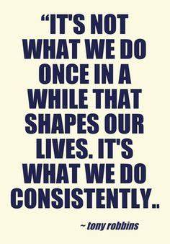
The school recognises that to achieve high standards of behaviour and discipline, it takes a whole school approach starting with the ethos set by the head teacher. As a collective, it is the duty of every member of staff to always accept responsibility for instilling clear expectations to achieve high standards of behaviour and discipline:
For successful outcomes, staff must consider:
- Always taking responsibility for discipline, including in the playground and the corridors.
- Using positive praise and reward to secure appropriate behaviour responses.
- Careful organisation and daily routines so that this is clear, concise and consistent for the children.
- Providing appropriate work that engages and focuses the children (planning, pitch, pace, participation etc.).
- Strategies that avoid conflict, humiliation and confrontation in the classroom.
- Following the school golden rules and referring to them regularly.
- Using the school reward system consistently so that all pupils are well motivated.
- The effective use of school sanctions as necessary.
- What is meant by bullying, and that it will not be tolerated. Where bullying is identified, staff should refer to the Anti-Bullying Policy and seek support from a member of SLT who will support the process.

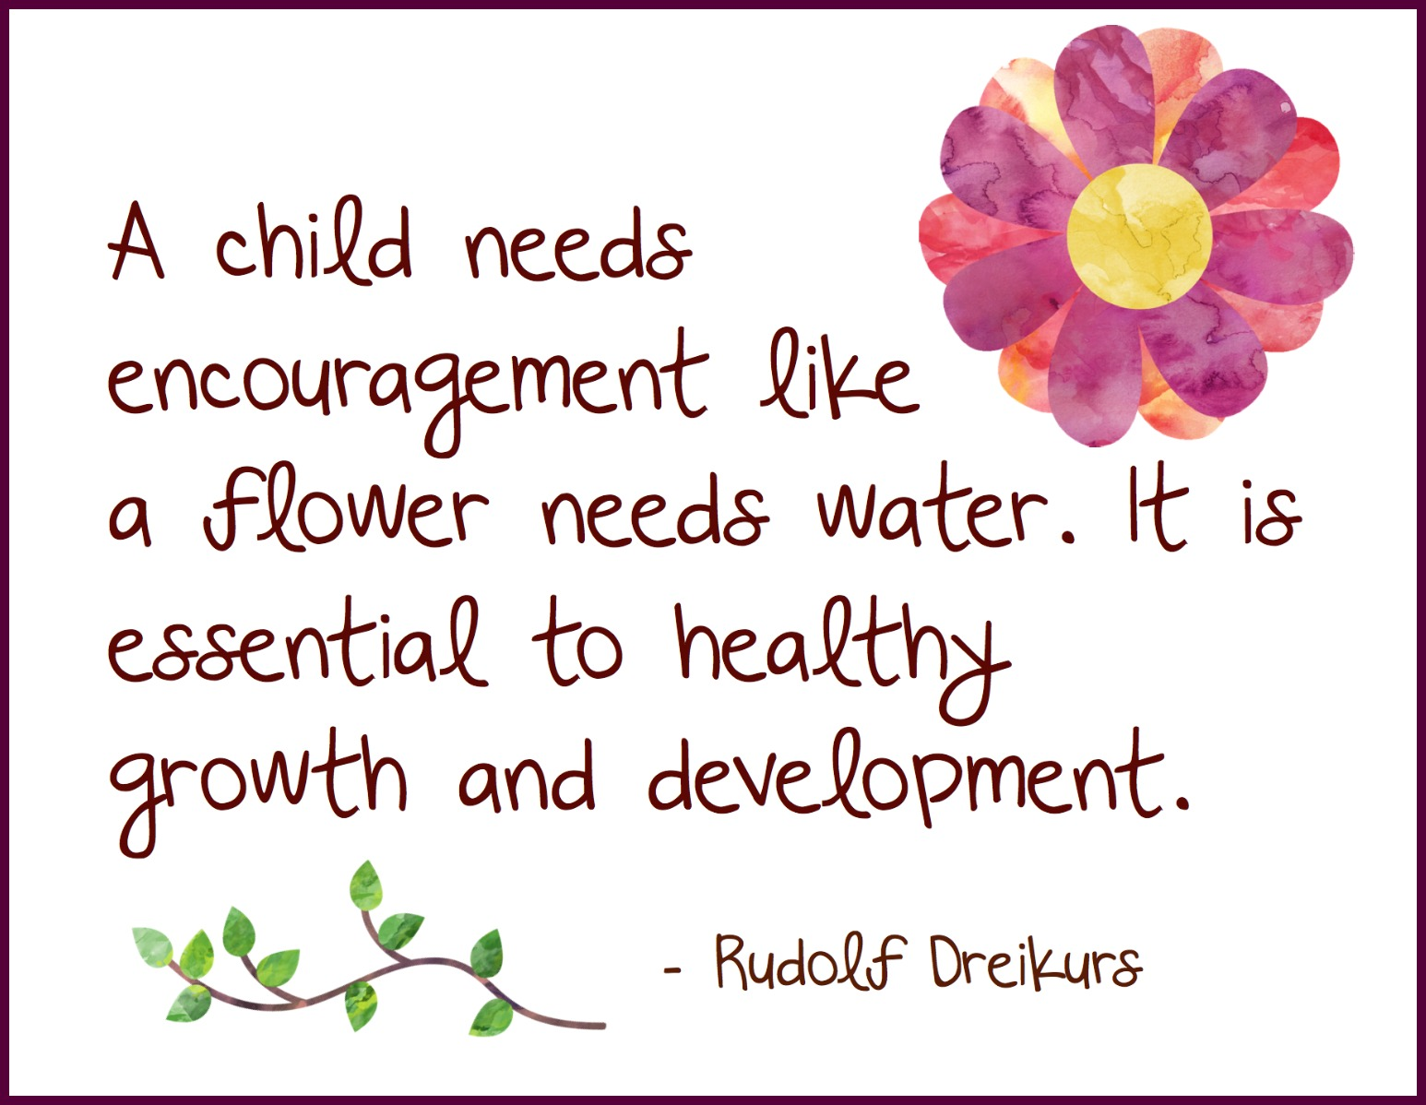
Positive Praise

Praise and reward have great emphasis as children will achieve more, be better motivated and behave better, when staff commend and reward their successes rather than focus on their failure. Praise has a reinforcing and motivational role. It helps a child believe he/she is valued. Praise can be delivered in formal and informal ways, in public or in private; it can be awarded to individuals or to groups; it can be earned for the steady maintenance of good standards as well as for achievements.

Teachers should encourage the ownership of values using school rules and class rules should be developed with pupils at the beginning of the school year to set clear expectations with the majority of children reaching a certificate milestone by the end of each term.

Nine Mile Ride Primary School has clear roles and responsibilities that are designed to set high standards of behaviour and to be consistently applied by members of staff. These expectations of behaviour are to ensure maximum learning takes place.

Shouting must not be used as a classroom management technique; however, there may be occasions when it is necessary to use a raised voice e.g., to re-establish control, be heard on the playground etc. If, in exceptional circumstances, a child needs to be removed from class, a Team Leader should be sent for. If unavailable, the deputy or most senior staff member available should be called.

Movement in and around school

All movement in and around school should be purposeful. Staff should see that all children are suitably supervised when moving around the school. Expectations of behaviour of children sent around the school with messages or to show good work should be clearly stated and frequently reinforced by appropriate rewards when followed.

Children not behaving appropriately should be reminded of what is expected and encouraged to behave better, or face sanctions for repeated lapses.

If a child should run out of school for whatever reason, staff should never run after them as they may be placing a child in greater danger by doing so. The head teacher or a member of the senior leadership team should be informed immediately, and lessons returned to normal as quickly as possible.

In most cases the child will remain on site, stay within visual contact or quickly return. Once the child has calmed down, a senior leader or appropriate staff member will attempt to approach the child and calmly persuade him/her to return to school and discuss the situation. If the child leaves the site, parents and police should be informed immediately.

Upon returning to school, it must be made clear to the child that there is no justification for leaving the premises and alternative strategies explained e.g., voluntary ‘Time Out’. As well as trying to solve the cause of the problem, the child must be left in no doubt as to the dangers they are exposing themselves to and how seriously the school views this behaviour.
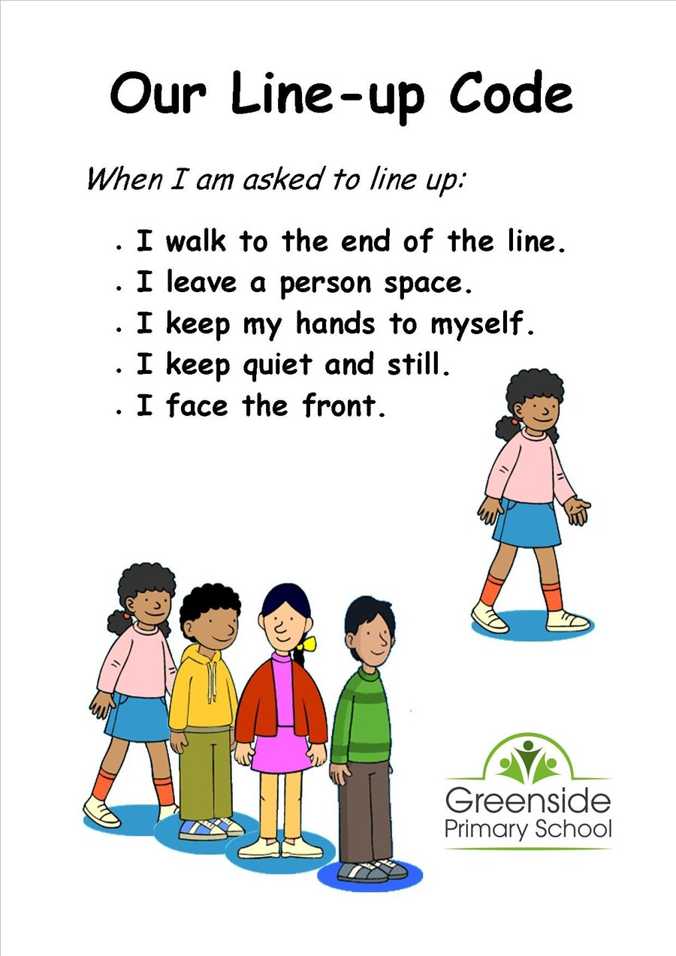

Start of the Day
The start of the day will be a soft start with the green gates opening from 8:30am for all Y1-6 pupils. Registration for Years 1,2, & 3 will close at 8:45am. Registration for Years 4,5, & 6 will close at 8:40am. A member of staff will be timetabled over the course of the week so that there is a point of contact for any parent with a question or query. Why- This enables us to welcome the children when they come through the gate and also give parents the opportunity to share any information with us before the start of the school day. It also shows that we are a staff that are approachable, friendly and visible.
Soft Start in place for Foundation Stage children from 8:40- with registration being at 8:50am eventually; however, there will be leeway over the first couple of weeks until the children settle. Children will enter via the bottom gate. There will always be members of staff available once the FS gate has opened.

Playtime Supervision

Teachers and Teaching Assistants are required to perform supervisory duties including playtime supervision. A minimum of two staff members are required to supervise playtimes for each playground. Supply teachers should cover the duty of absent teachers but should never be without support.

When on duty, staff should circulate and take the opportunity to socialise with children from other classes, whilst maintaining an overview of the play area and spotting potential problems before they escalate. At the end of playtime, Key Stage 1 the children should walk to designated class lines in alphabetical order and line up. Key Stage 2 should line up (in alphabetical order) as promptly as possible after hearing the chime. Staff send children into school a class at a time, ensuring there is no running or congestion. Good behaviour whilst entering school should be reinforced with praise and the awarding of a ‘Smiley’. In suitable weather conditions the field may be used at playtimes. This is the decision of staff on duty. In poor weather, children should not go outside at break time. In these circumstances, the Year 6 children will be ‘wet-play’ monitors.
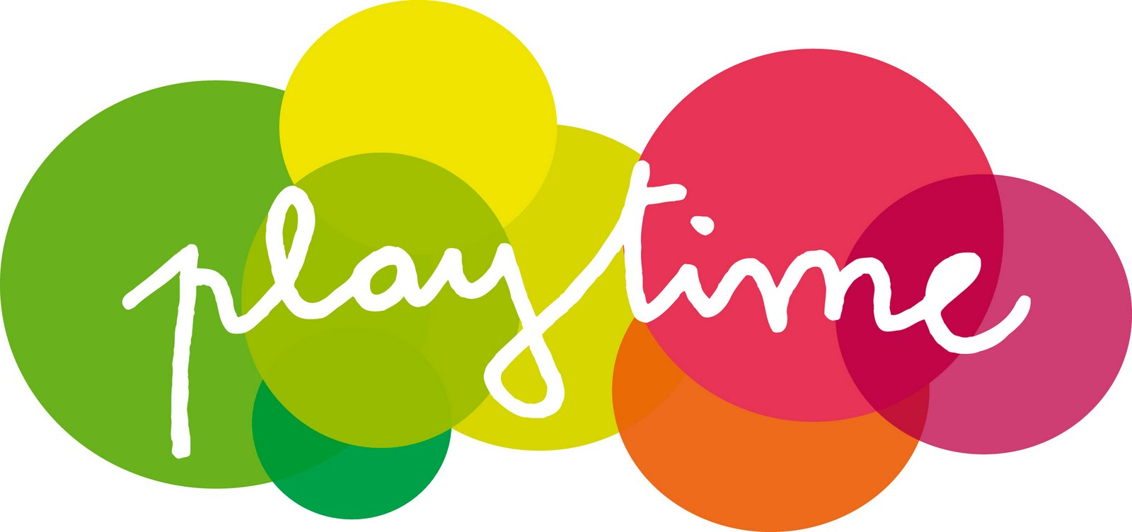

Playground Procedures

To influence behaviour when dismissing children at playtime, lunchtime and home time, teachers should supervise their own children in the corridor, putting on coats etc. Children should be well informed by their teachers that if they do not put on their coats at the beginning of playtime in cold or inclement weather, then they will have to do without for the whole of playtime. Children are not allowed back into school during playtimes for any reason other than to visit the toilet. Please remind them to collect their property at the end of each session.
Children on KS2 playground should use the library toilets at playtime and lunchtime, seeking permission from an adult on the playground. Adults should ensure that not too many children are in the toilet at any time. If a child needs to enter the school during lunchtime for any reason, a ‘Hall Pass’ should be given to them by a lunchtime controller.
Children on the KS1 playground may use their own toilets. At lunchtime, a plastic band will be given to a child by a lunchtime controller to allow them to use the toilets. Only six bands will be available on this playground.

Children may not bring balls or equipment from home for use at playtimes but may use those supplied by the school. Footballs will only be allowed at lunchtime. They should be lightweight and should only be used on the KS2 playground or the field in appropriate conditions at the discretion of the duty teachers. Any misuse of playground equipment will lead to confiscation.

Any other poor behaviour at playtime should be dealt with by the teachers on duty or reported to a senior member of staff according to severity or frequency.

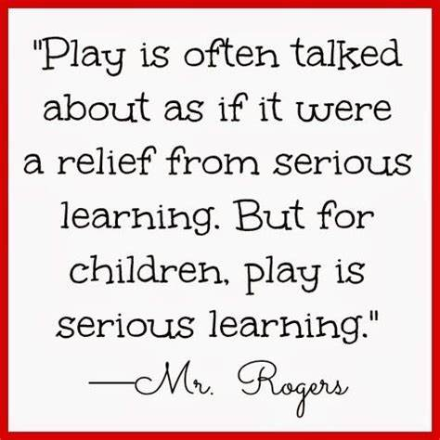
Any child needing medical attention at playtime will be dealt with by the appropriate member of staff with first aid training on the playground, unless additional First Aid support is required. If this is the case, contact the school office in the first instance.

Rewards

Nine Mile Ride Primary School believes that the best behaviour management is based upon mutual respect and where rewards are used to encourage good behaviour. Nine Mile Ride has designed and adopted a consistent approach for rewarding and encouraging good behaviour, effort and manners based on the collection of Smileys (See appendix 1). Smileys may be awarded for any actions, deeds or attitudes which are deemed noteworthy and may include:

A Smiley can be awarded by any staff member to any child at any time. This reinforces our philosophy that the care of all our children is the responsibility of all adults in school and once awarded, a Smiley can never be deducted. They are intended to help staff focus on positive rather than negative behaviour. All awards will be presented in a whole school assembly and recorded on each child’s individual Smiley Card.

A Smiley can be awarded by any staff member to any child at any time. This reinforces our philosophy that the care of all our children is the responsibility of all adults in school. If all children in a class achieve Bronze, Silver or Gold Awards they may have an appropriate class treat of their choice including class party, class disco, additional art/PE, DVD etc. The reward should reflect the achievement. Smileys awarded to children should be recorded on Arbor.

Certificates: A weekly celebration assembly is dedicated for the praise and recognition of children who have made particularly noteworthy progress for attainment, achievement and/or attitude both in and out of school.

Zone Boards: Each classroom has a Zone Board with names of the class children individually placed in the Green Zone at the beginning of the school day. In KS1 and 2, at the end of the morning all those who have moved down a zone move back up one zone (i.e. Orange to Green, Red to Orange). All behaviour incidents which result in a child being moved to Orange, Red or Gold should be reported on Arbor.

If a child is placed on orange three times in a half term, an orange letter will be sent home to inform parents and will result in a loss of one playtime for the child.

Exemplary Behaviour: Exemplary behaviour is rewarded by children being moved into the Gold Standard Zone. Appropriate praise is given in class to highlight the behaviour. The child receives 5 smileys. Any child that has remained in the green zone for the whole week, will be moved to the Gold Standard zone on a Friday afternoon and receive 5 smileys. Teachers may reward children with Golden Time as appropriate.

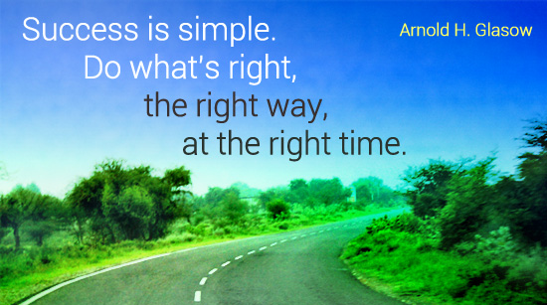

Sanctions

Nine Mile Ride Primary School believes that the best behaviour management is based upon mutual respect. Where sanctions are needed, they are best applied by the member of staff concerned, with support from line managers where appropriate. The aim is always to repair and improve relationships whilst enabling pupils to understand the consequences of their actions.

Pupils have a right to expect fair and consistently applied sanctions for poor behaviour. Sanctions can be applied for incidents outside of the school grounds e.g. on the way to and from school; on school trips etc. They may also be applied if a pupil brings the school into disrepute.

Consistently applied sanctions will differentiate between serious and minor offences and there will be provision for flexibility to take account of individual circumstances. Any sanction will be proportionate and corporal punishment is illegal in all circumstances.

Nine Mile Ride has a ladder of consequences to register disapproval of unacceptable behaviour which includes the use of warnings in the first instance. Warnings allow the child to learn from their mistakes and modify their behaviour as a result. If two verbal warnings do not work, zone boards are used in a sensitive way, so that no child is humiliated. Once again, children can learn from their mistakes and modify their behaviour. Zone boards are intended to:

Zone board behaviour will be monitored closely to ensure that support can be put in place for any child demonstrating persistent orange or red behaviour.

When sanctions are applied, children should be helped to understand why their behaviour is not acceptable.

There are some actions that will move a child directly to the Red Zone. They are:

At this point a red letter (appendix 5) is completed and the child will be spoken to, issued an appropriate sanction and given the signed red letter. This form is photocopied and once the staff member has spoken to the parent/carer, the original will be sent home. The photocopy will be put in the Behaviour File (Deputy Head's Office). A red letter will not be issued to Foundation Stage children, but staff will contact and speak through the behaviours with the parent.

A red letter may not be sent home if a member of staff has been informed of an incident but has not witnessed it. Staff shall use their professional judgement to deal with the situation and will record the behaviour so that it can be monitored but it will not be sent home. Sanctions will be up to the professional judgement of the member of staff dealing with the situation. The child who is issued a red letter, will move to the red zone on the zone board. Children should be familiar with the procedures and know what will happen next if they refuse the sanction or continue with the negative behaviour choice. Professional judgement is required regarding which sanction is most suitable, given the behaviour displayed.

As a response to a pupil falling below the expectations of the school, a range of sanctions may be warranted but not limited to the list below:
- Verbal warning.
- Extra work or repeating unsatisfactory work until it meets the standard appropriate for the pupil.
- Confiscation: items can be taken from a pupil and retained.
- Give a verbal apology or write letters of apology.
- Loss of break and/or lunchtime.
- Loss of privileges.
- Internal exclusion: isolation of a pupil for part or all the school day, completing work under the supervision of a member of staff.

Expressing a concern about a sanction

Parents and carers have the right to raise their concerns; however, it is expected that parents will support the school and take its judgement as a professional one undertaken in the best interest of their child.

If the sanction involves a fixed term or permanent exclusion, then separate processes for making representations apply. Disagreement with the imposition of a sanction is not itself grounds for complaint.

If a parent or carer disagrees with a sanction their child has received, they can seek to resolve the matter and should contact the members of staff below in the order given:

If after the steps above have been followed and when a parent/carer is still not satisfied, then they can make a complaint as set out in The Circle Trust’s Complaint Policy.

Confiscation

Nine Mile Ride Primary School allows a member of staff to confiscate, retain or dispose of a pupil’s property so long as it is reasonable in the circumstances.

The law protects member of staff from the liability for damage to, or loss of, any confiscated items so long as they have acted lawfully.

Nine Mile Ride School may:

- Return the confiscated item at the end of the school day to the pupil.
- Return the confiscated item after a longer period e.g. released on the last day of a term;
- Return the confiscated item to a parent/carer.

Dealing with Mobile Phones and other Electronic Devices

The school permits pupils to bring in a mobile phone once a consent form has been signed by both the headteacher, child and parent/carer.

Mobile phone use is unauthorised for use during the entire school day and any unauthorised use of a mobile phone will result in a sanction and/or confiscation.

Pupils (with permission) bring a mobile phone into school at their own risk. Nine Mile Ride Primary is not liable for loss or damage to a phone and as such recommends that very expensive phones are not brought into school.

Mobile phones may also be confiscated. If a member of staff deems it necessary not to return a mobile phone at the end of the school day, then the parent/carer will be rung to be informed and to see if they wish to collect the mobile phone.

Nine Mile Ride Primary School permits a member of staff (nominated by the Headteacher) to examine the content of electronic devices if there is good reason to do so.

If offensive, inappropriate or material that could cause intended or unintended harm is found they may retain the device, or they may erase the material if there is good reason to do so. If the material is of a very serious nature and certainly in respect of safeguarding a young person, it will require the involvement of the police.

The member of staff must have regard to following guidance issued by the Secretary of State when determining what might constitute “good reason”. This would include the member of staff reasonably suspecting that the data or file on the device in question has been, or could be, used to cause harm, to disrupt teaching.

Powers to use reasonable force

Members of staff have the power to use reasonable force to prevent pupils committing an offence, injuring themselves or others or damaging property; however, force may not be used to conduct a search of a pupil.

Anti-bullying statement

Bullying of any kind (physical, verbal and because of race, religion, gender or sexual orientation) is unacceptable and will not be tolerated.

At this school, we believe that bullying is an anti-social behaviour that may have very serious consequences for a pupil. We are committed to providing a caring, friendly, and safe environment for all members of our school community so that pupils can learn in a safe and secure environment without fear of being bullied.

Nine Mile Ride School actively promotes a climate of co-operation and positive behaviour to reduce the number of incidents and the likelihood of bullying occurring.

The setting of standards with pupils regarding anti-bullying are promoted:
- At whole-school level, through assemblies and anti-bullying initiatives.
- At classroom level, throughout the curriculum, namely Personal, Social and Health Education (PSHE) programme.

Pupils are encouraged to share incidents of bullying which they experience or of which they may be aware with members of staff. In these circumstances staff will respond sensitively, take the expression of concern seriously and ensure that the matter is fully investigated, and appropriate action taken in accordance with this policy.

Nine Mile Ride Primary recognises the important part parents/carers play in supporting their children and welcomes all reporting to staff regarding bullying concerns.

All members of staff are responsible for the rigorous application of this policy and the requirement to take action when bullying is reported; however, this will be done in conjunction with SLT who will offer support via the process.

How will Nine Mile Ride support pupils who are experiencing behavioural difficulties?

Where it has been noted that behavioural concerns are becoming persistent or frequent, we will ensure that pre-emptive measures are taken to prevent the escalation of the difficulties and will offer the following support as a guideline:
- Contact with parents/carers at an early stage. Regular contact if there is escalation.
- Complete a Behaviour Support Request referral.
- Use of behaviour logs to analyse patterns of behaviour.
- Access to Thrive sessions and Nurture.
- Placement on school success contract.
- Placement on behavioural contract.
- Use of internal support systems as required.
- Consider working with or referral to external support agencies where needed.
- Rewards and celebration of successes.
- Behavioural targets set through Pastoral Support Plan.
- Managed move to another school setting.

Behavioural difficulties can be a result of unmet need; therefore, the school will take a holistic view of patterns of behaviour, type of behaviour and impact of support strategies when determining the most appropriate sanction or indeed reward.

At the core of our behaviour management process, we will endeavour to support parents/carers to work with the school toward finding a resolution.

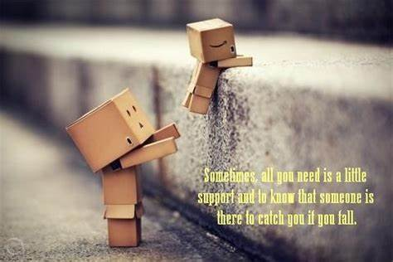

Appendix A -
Behaviour Standards and Expectations

Nine Mile Ride Primary School has clear expectations that are designed to set high standards of behaviour and to be consistently applied by members of staff. These expectations of behaviour are to ensure maximum learning takes place.

Expectations of our staff include:

Model and encourage good behaviour through a mixture of high expectations; clear procedures; an ethos that shines the light on the positive; fosters discipline and mutual respect.

Ensure that pupils understand that anti-social behaviour is never acceptable.
- Encourage pupils to take ownership of their behaviour using school rules. (See below.)
- Champion the rights and responsibilities for all pupils. (See below.)

Use praise and reward as children will achieve more, be better motivated and behave better, when staff commend and reward their successes rather than focus on their failure.

Use praise as a reinforcing and motivational tool. It helps a child believe he/she is valued. Praise can be delivered in formal and informal ways, in public or in private; it can be awarded to individuals or to groups; it can be earned for the steady maintenance of good standards as well as for particular achievements.

Support pupils to reach a bronze certificate by the end of the autumn term, silver by the end of spring and gold by the end of the summer term.

Expectations of our learners include:

Display courtesy, consideration, and tolerance for others.

Always follow school and class rules.

Follow instructions given by all members of staff and/or other adults working with staff.

Attend school in full uniform, worn correctly, on time each day with the correct equipment and being punctual to all lessons.

Complete work to the best of ability.

Respect the people, environment, equipment and facilities.

Be ambassadors for the school at all times.

Appendix B
Golden Rules
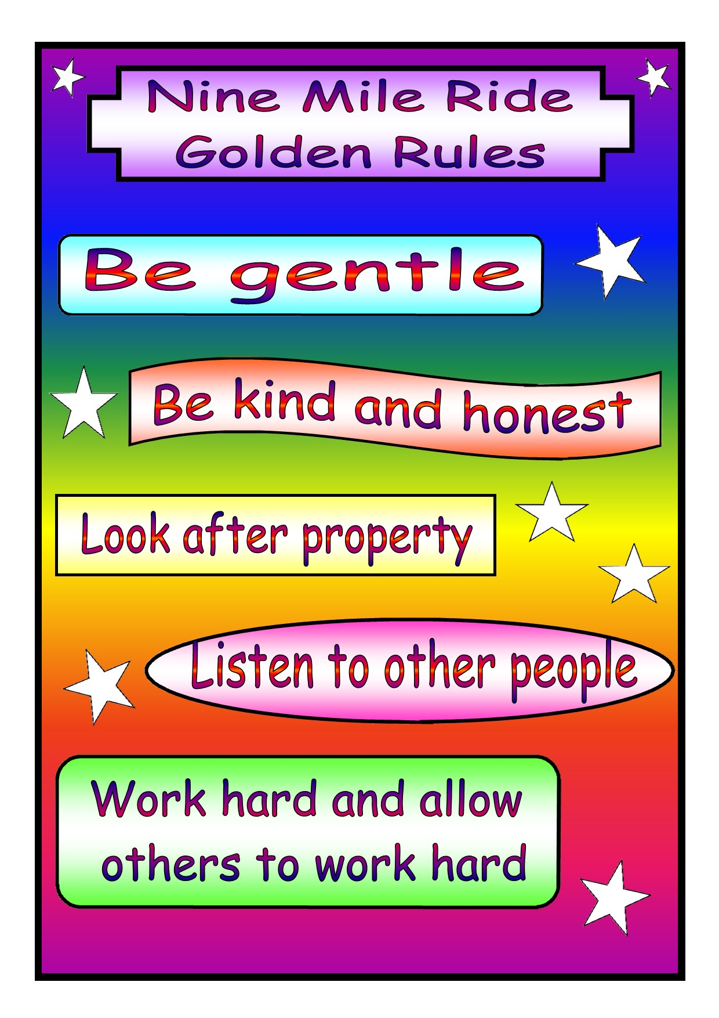

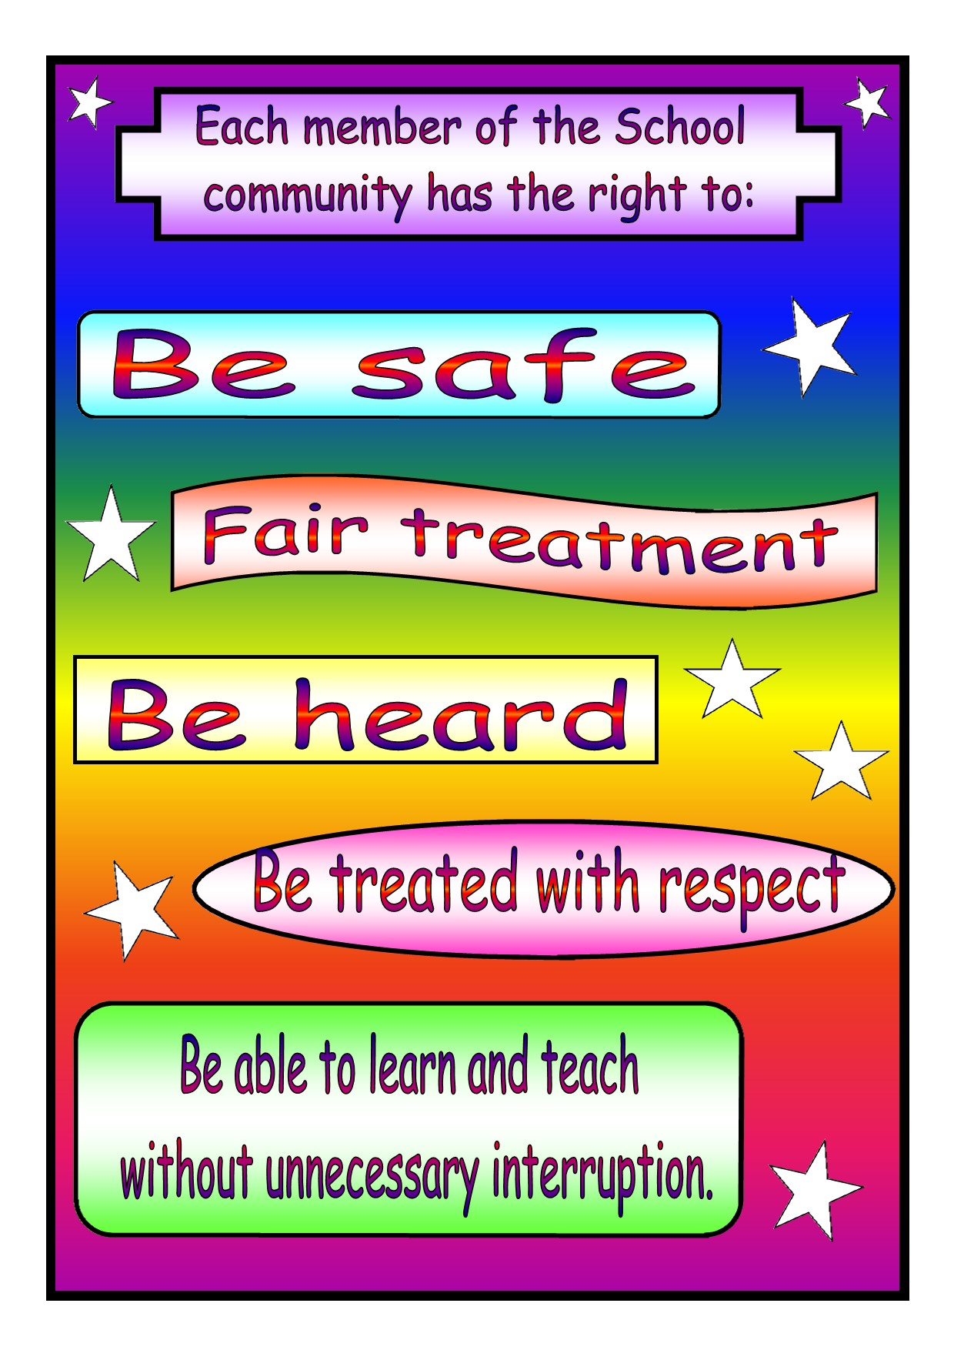
Rights and responsibilities

Appendix C
Smiley Expectations
A ‘smiley’ can be awarded by any staff member to any child at any time. All staff should reward and reinforce positive behaviour as it occurs. This reinforces our philosophy that the care of all our children is the responsibility of all adults in school.
The expectation is for the majority of children to reach milestones by the end of each term:
Bronze by the end of autumn term | Silver by the end of spring term | Gold by the end of summer term
Star Award for exceptional achievements (400 smileys)
Platinum Award for outstanding achievements (500 smileys)
Award level | Examples but not limited to
Class teacher  1-5 smileys | Smileys may be awarded for any actions, deeds or attitudes which are deemed noteworthy and may include: -  - Particularly good work/effort  - Consistently adhering to school rules and  - Helping another child on the playground  - Demonstrating growth mind set skills and good learning behaviours  - Consistently engaged in learning opportunities  - Showing respect for others  - Responding to feedback to improve learning  - Displaying good manners  - Achievement out of school  - Gold Standard behaviour (5 smileys)  - Homework always on time and completed to a very high standard
5 Smileys | Award 5 smileys every Friday if child has been on Green Standard behaviour all week.
Teacher award  10 smileys | - Managing distractions over a period of time  - Responding to feedback to improve learning consistently  - Helping an adult or in the classroom without being asked  - An outstanding piece of work  - Produces more than is expected/goes beyond the requirements  - Representing the school e.g. sport, music  - Doing extra research at home  - Going out of their way to be a good role model
Team Leader  50 smileys | - Supporting other children in their learning on a regular basis  - Independent project completed at home e.g. 3d model  - Achievement out of school
Headteacher  100 smileys | - A great attitude to learning, always going the extra mile  - Exceptional achievement out of school  - Being an excellent ambassador for the school

Appendix D
Ladder of Consequences-classroom
Step 1- Warning
If I am not displaying green behaviour my teacher will give me two warnings. I know that there will be consequences if I continue to make the wrong choices.

Step 2 – Orange Zone
I will be placed on orange and may be moved to sit on my own until I calm down.

Step 3 – Red Zone
If I do not calm down and make the wrong behaviour choices, I will be sent to another teacher to work alone.
Privileges will be taken away from me.

Step 4 – Phase Lead Involvement
If I continue to make the wrong behaviour choices, I will be taken to the team leader to work.
I will be placed on the red zone and a red letter will be sent home.
Sanctions will be put in place.
If I continually make the wrong choices, I will be placed on Step 5
Step 5 – Success Contract
The class teacher will complete a Success Contract and targets for my behaviour will be set.
My behaviour will be monitored, recorded daily and shared with my parents.
Sanctions will be put in place.
If I do not meet my targets, I will be placed on Step 6
Step 6- Behaviour Support Referral
I will have a behaviour contract set and I MUST keep my targets.
Sanctions will be put in place.
If my behaviour does not improve, I will be placed on Step 7
Step 7 – Internal Suspension
My parents will be informed by letter that I am not allowed to be taught in class
Sanctions will be put in place.
If my behaviour does not improve, I will be placed on Step 8 then 9
Step 8 – Fixed Term Suspension
My parents will be informed by letter that I am not allowed to come to school for a set period of time.
This will be on my school record forever.
Sanctions will be put in place, and external support will be sought.
If my behaviour does not improve, I will be placed on Step 10
Step 10 – Permanent Exclusion
My parents will be informed by letter that I am not allowed to come back to Nine Mile Ride.

Appendix E
Ladder of consequences-Lunchtime
Step 1
If I am not displaying green behaviour, a member of the lunchtime staff will give me a warning to stop. I know that there will be consequences if I continue to make the wrong choices.

Step 2
If I continue to make the wrong choices. I will be given a final warning and asked if I understand.

Step 3
If I receive a final warning and then make the wrong choice, I will be placed on orange.

Step 4
If I am placed on orange and continue to make the wrong choice, my teacher will be informed, and I will be placed on red and a red letter will be sent home. I will lose further playtimes.

If I continually make the wrong choices, I will be placed on Step 5
Step 5
I will be put on a ‘Lunchtime Agreement 'and the team leader and my parents will come to school and help me set targets for my lunchtime behaviour.

The following behaviours are instant red and would mean that a child would go straight to Step 4.
- Fighting
- Lack of respect
- Swearing
- Spitting
- Bullying (physical, verbal and because of race, religion, gender or sexual orientation)
- Racial abuse
- Vandalism
- Theft
- Verbal/physical assault on adults

ORANGE ZONE LETTER

To the Parents/Guardians of …………………………………………… Date…………………
Dear Parent,
As part of our behaviour policy I am writing to inform you that …………………..……………………… has been in the orange behaviour zone on three occasions for:
Talking and distracting others |  | Not lining up
Not following instructions |  | Talking in assembly
Late or missing homework |  | Running in school
P.E. kit not in school |  | Other

Brief description…………………………………………………………………….……………………………………………………………………….
As a result of their behaviour your child has missed a playtime. We would ask that you discuss your child’s behaviour with them and stress that poor behaviour can cause disruption to their learning and potentially other children’s learning.
Yours sincerely
Class Teacher
…………………………………………………………………………………………………………………………………….………………………………
FAO Class Teacher ……………………………….………………….
I acknowledge receipt of the letter informing me that my child …………………………………… has been in the orange behaviour zone on three occasions.

Signed ………………………………………………………… Date: ………………………
(Parent/Guardian)

RED ZONE LETTER

To the Parents/Guardians of…………………………………………………. Date………………………
Dear Parent,
As part of our behaviour policy I am writing to inform you that ………………………………. has been in the Red Behaviour Zone for the following:
Persistent Disruption |  | Verbal (incl Swearing)
Physical |  | Bullying
Racist Incident |  | Other

Date, time and place of incident: ……………………………………………………………………………………………………………………
Brief description of the event: ………………………………………………………………………………………………………………………..
…………………………………………………………………………………………………………………………………………………………………………
Name of adult who dealt with the incident: …………………………………………………………………………………………………….
Is action required by the headteacher: ……………………………………………………………………………………………………………
We would ask that you discuss your child’s behaviour with them and stress that poor behaviour can cause disruption to their learning and potentially other children’s learning.
Yours sincerely
Class Teacher Signature Head / Deputy Head Signature
……………………………………………………………………………………………………………………………………………………………….……
FAO CLASS TEACHER ……………………………………….
I acknowledge receipt of the letter informing me that my child ……………………………………
has been in the Red Behaviour Zone.
Signed ………………………………………………………… Date: ………………………
(Parent/Guardian)

Nine Mile Ride Success Contract
Name:
Start date:

Aim (2O max): No. Achieved: Target met? Week:
Targets:
1.
2.
3.
 | Monday | Tuesday | Wednesday | Thursday | Friday
1
2 | BREAK | BREAK | BREAK | BREA | BREAK
4 | LUNCH | LUNCH | LUNCH | LUNCH | LUNCH
5
REWARDS
YELLOW (5 yellow=……)
GREEN
CONSEQUENCES *Stay on contract

Signed ____________________ ___________________________ __________________________
Teacher Parent Child

